

Introdução à Inteligência Artificial

2021/2022 – 2º Semestre

Pratical Work Nº2: *The Slow and the Calm Darwin’s Edition.*

Report

Sancho Simões | 2019217590 | sanchosimoes@student.dei.uc.pt | PL6

Tiago Ventura | 2019243695 | tiagofilipe@student.dei.uc.pt | PL6

May 1st of 2022

Goal 1- Modelling and Development of Genetic Algorithm

This report is related to the second practical work of the Artificial Intelligence Fundamentals subject and aims to develop skills related to the analysis, development and implementation of adaptive agents. Therefore, it is based on the study of an Evolutionary Algorithm, and several scenarios with different parameters of evolution should be tested. In the Unity package provided, there are vehicles consisting of:

-8 vectors that structure the vehicle.

-0 to 15 wheels.

Then we programmed 4 essential functions of our Evolutionary Algorithm:

-Recombination

-Mutation

-Selection of Parents

-Selection of Survivors

-Parameterization

-Fitness

After implementing these functions, it is important to test and observe the behavior of the vehicles and, to do so, a scene (Fig. 1) already developed in the supplied code was used.

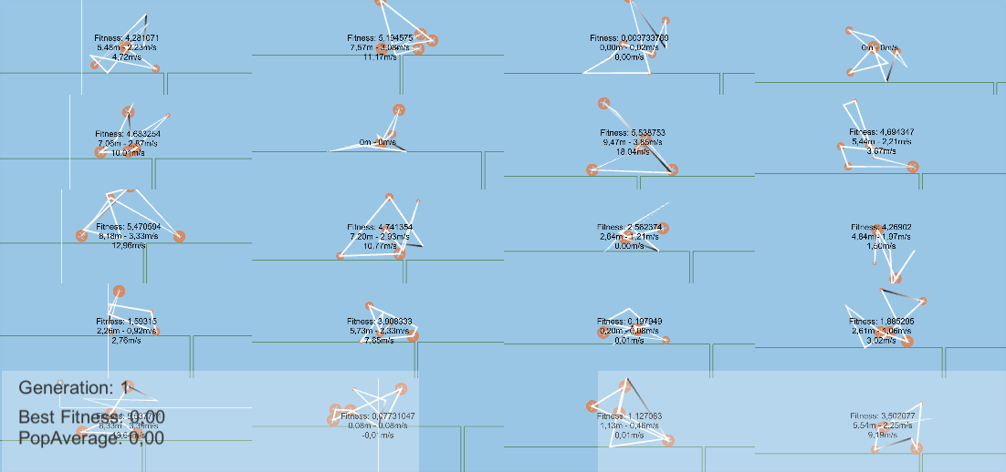

Fig 1- Developed scenario

Our main goal was to develop a fitness function capable of mutating and creating and individual which are able to reach the end of the road. After testing some combinations of referred function, mainly based on the wheels and max speed, we decided that using just the max distance as a factor for the fitness function was our best option since our goal was to achieve an individual capable of reaching the end of the road. Each road had 656 meters that means and individual with a fitness of 656 is potentially the best for the aimed result. After some testing with the various given parameters and doing 3 times the test for each group of parameters we achieved a medium of 2/3 individuals reaching the end of the road after 30 generations and fitness average of 182,63 as seen in Figure 2.

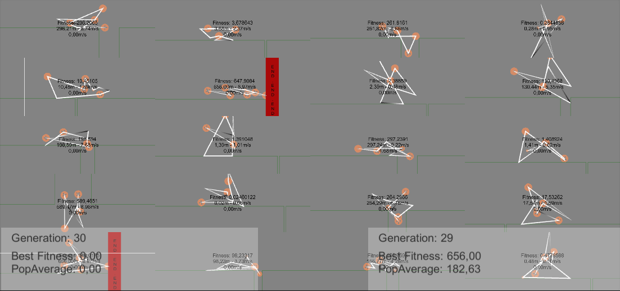

Fig 2- Generation 30 scenario.

Overall, we reached our goal successfully but we can also test other things such trying to create the fastest individual or the fasted individual that can reach the end of the road with the less possible number of wheels. There is a big variety for the fitness functions that can be used and all of them depends on the aimed goal.